Civil war in Liberia

UNSC Resolution: | 1408
Date of adoption: | 6-May-2002
Operative paragraph: | 1408
Demand number: | 1408,0711

Sarah-Myriam Martin-Brûlé

Wording of demand

establish an effective Certificate of Origin regime for Liberian rough diamonds that is transparent and internationally verifiable, bearing in mind the plans for the international certification scheme under the Kimberley Process, and provide the Committee with a detailed description of the proposed regime

List of addressees of the demand

Government of Liberia

Short-term compliance

Description of the addressee(s)’ conduct

“9. With regard to paragraph 2 (c) of resolution 1343 (2001), the Government of
Liberia reaffirmed its ban on the importation of uncertified rough diamonds and the
related ban on the export of Liberian diamonds, adding that the ban was being
vigorously pursued through the Ministry of Finance, as well as through customs and
security personnel of the Ministry of Justice who have been stationed at every port
of entry. »
(…)
“10. In addition to those measures, the Government of Liberia reported that the
Ministry of Lands, Mines and Energy was currently engaged with the High Diamond
Council, which has now formally drawn up a draft plan of action for Liberia’s
diamond certification regime, under the Kimberly Process, with a view to putting in
place a certificate of origin regime for Liberia. In this regard, members of the
Security Council sanctions Committee on Liberia will recall that the Minister of
Lands and Mines of Liberia had, early in October 2002, been granted a waiver of the
travel ban to facilitate his official visit to South Africa in pursuance of the above mentioned objective.”
(…)
“20. The Government stated that most of the diamond-producing areas were in the
combat zone in north-eastern Liberia and that it was closer and easier to get
diamonds to Sierra Leone than to Monrovia. Furthermore, the Liberian economy did
not have the capacity to sustain the diamond trade.
21. Independent sources indicated that there was no proof of direct importation of
rough diamonds to Liberia from Sierra Leone. There was consensus that the
Government of Liberia received taxes from diamond concessions but had no control
over the diamond trade. Those sources indicated that there was now a reverse flow
of indirect trade in diamonds from Liberia to neighbouring countries.
(…)
24. The Government of Liberia has tried to comply with the Security Council
resolution on the issue of a certificate of origin for rough diamonds. The
Government alleges that its efforts have been stalled by some powerful interests in
the Security Council. Consequently, the Government has not been able to establish a
certificate of origin. However, Liberia has continued to participate in the Kimberly
Process and efforts are ongoing to reach agreement on the certificate of origin.”

United Nations Security Council. First report of the Secretary-General pursuant to Security Council resolution 1408 (2002) regarding Liberia, 22 October 2002

152. Limited progress has been made in establishing a credible diamond
certification system since the Panel submitted its previous report (S/2002/470).
Reluctance by the responsible Minister to delegate responsibility for this important
task has contributed to the delay. Minister Dunbar blames the Security Council’s
travel ban for his inability to travel, resulting in the lack of progress in setting up a
certification scheme. The Panel is aware that a member of the Security Council
Committee on Liberia discouraged the High Diamond Council in Antwerp to hold a
dialogue about certification with Minister Dunbar while he was in Belgium in
January 2002. This interference appears to have been overcome: although Minister
Dunbar still requires permission from the Security Council Committee to travel, his
staff are fully competent and do not fall under any travel restriction.
153. The Minister of Lands, Mines and Energy has remained in electronic contact
about assistance for setting up a credible certification system with the Director for
International Affairs of the High Diamond Council in Antwerp. This has produced a
draft of a plan of action.
154. The plan of action is a start. It suggests that the first step should be a neutral,
objective production assessment by an international diamond mining or geological
consultancy company of international repute. The purpose of this should be to identify
only those diamonds that have been produced from Liberian soil. The Panel has
continued to be told of stockpiles of diamonds of Sierra Leonean origin in Liberia and
these should not be laundered through the Liberian certificate of origin scheme.
155. A second step recommended by the plan of action is for a credible
organizational system for small-scale diamond miners. This would include a
detailed survey of who produces which type of diamond, and where. This road map
recommends that participants that produce diamonds and have rebel groups
suspected of mining diamonds within their territories are encouraged to identify the
areas of rebel diamond mining activity and to provide this information to all other
participants. This recommendation is not practical. The Liberian conflict is fluid and
it would be easy to launder conflict diamonds through this system. Diamonds only
from clearly defined and independently verified localities should at present be
considered for entry once a credible system is established.
The plan of action also contains a third section, on certification, which outlines
the minimum requirements that are needed for certification so as to ensure
compatibility with the Kimberley Process. The Ministry of Lands, Mines and
Energy has allocated two empty rooms in its building to house any future
certification scheme and has been in touch with a South African bank about

United Nations Security Council. Letter dated 24 October 2002 from the Chairman of the Security Council Committee established pursuant to resolution
1343 (2001) concerning Liberia addressed to the President of the
Security Council. 25 October 2002.

http://www.reliefweb.int/rw/RWFiles2002.nsf/FilesByRWDocUnidFilename/OCHA-64CUBY-unsc-lib-25oct.pdf/$File/unsc-lib-25oct.pdf

Assessment

Short-term compliance
No or marginal compliance (1) | X Medium low compliance (2) | Medium high compliance (3) | Full or almost full compliance (4)

Considerations underlying the assessment
According to the Panel of expert, within the six months following the adoption of the demand, “Limited progress has been made in establishing a credible diamond certification system s”

Medium-term compliance

Description of the addressee(s)’ conduct

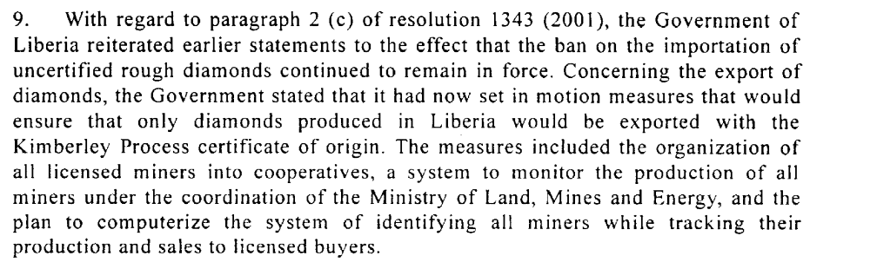
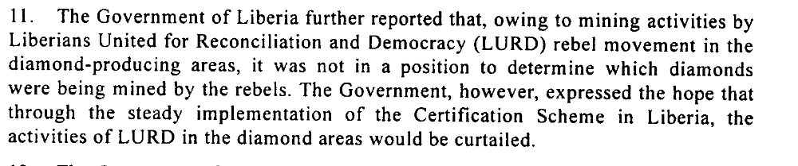
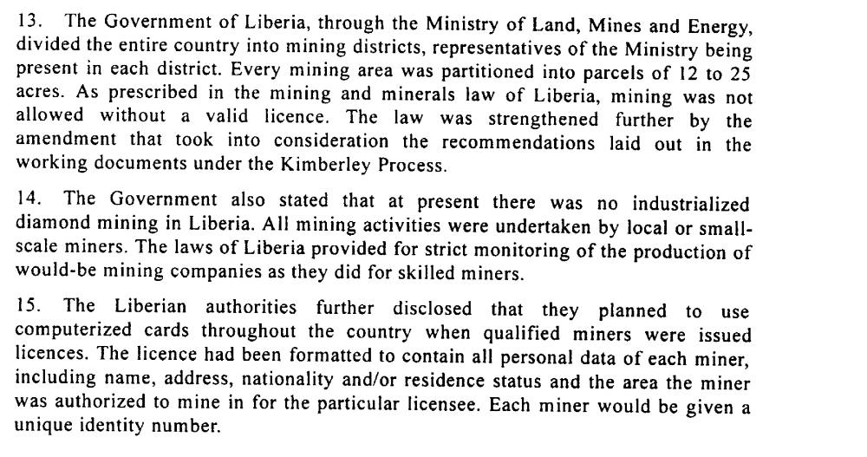
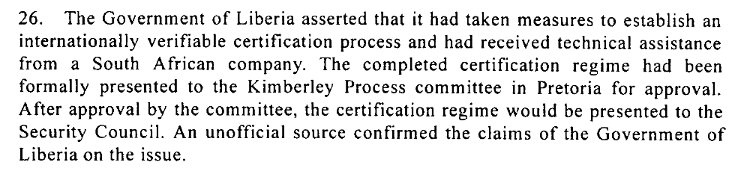
United Nations Security Council. Second Report of the Secretary-General Pursuant to Security Council Resolution 1408 (2002) regarding Liberia. 22 April 2003.

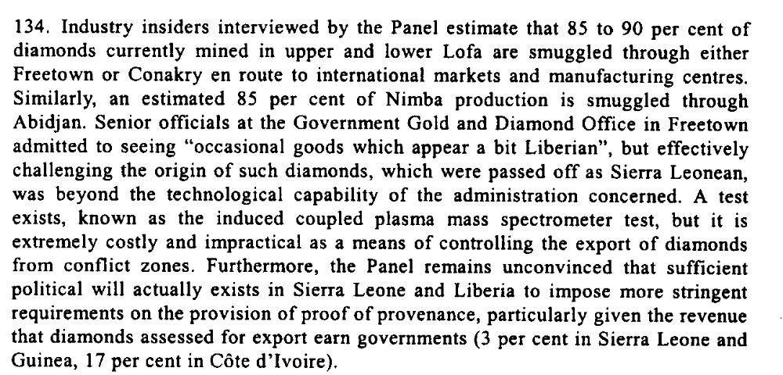
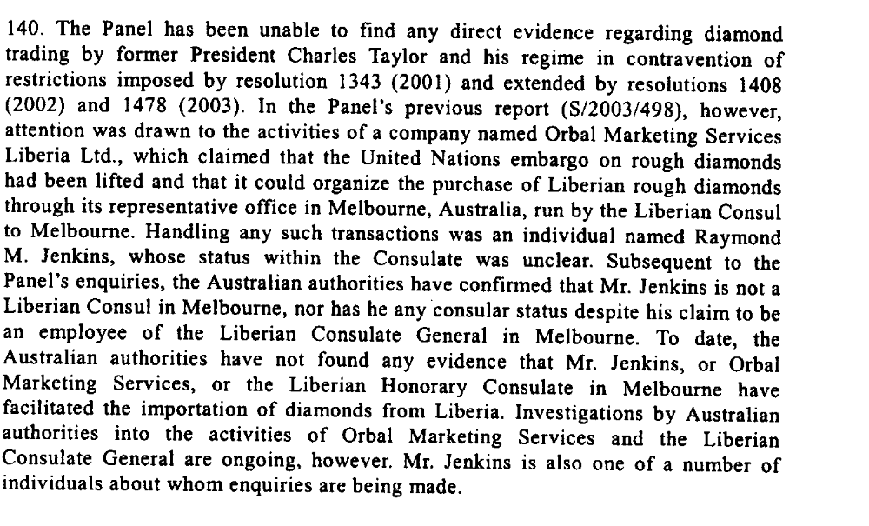
United Nations Security Council. Letter dated 28 October 2003 from the Chairman of the Security Council Committee established pursuant to resolution 1343 (2001) concerning Liberia addressed to the President of the Security Council.

In 2004

“The diamond embargo has been continued through to the current sanctions regime, due
to the NTGL’s lack of control over its diamond-producing areas and diamond industry more generally. At present, Liberia is still not in compliance with Kimberley Process (KP) requirements. While some progress has been made toward instituting essential government controls over diamonds, such as the passing of legislation designed to implement the KP, given the historical and current lack of control over natural resources and border regions in Liberia the time is not right for diamond export sanctions to be lifted. In addition to the lack of control the NTGL has over its territory, there is currently a lack of capacity, law enforcement and civil service infrastructure to adequately deal with the establishment of a diamond-trading regime. Moreover, there remains a regional network of actors involved in the diamond trade who would be able to and have previously, facilitated the illegal trade of diamonds from Liberia.”

(...)
“The government has also failed to prove its ability to implement the requirements of the Kimberley Process, as large-scale diamond mining takes place in the absence of government supervision.”

Global Witness Report 2004. “Dangerous Liaisons The continued relationship between Liberia’s natural resource industries, arms trafficking and regional insecurity”. 8 December . A briefing document submitted by Global Witness to the UN Security Council.
http://www.globalwitness.org/media_library_detail.php/128/en/dangerous_liaisons

“The United Nations Panel of Experts on Liberia, in its report of March 2005, stated that in Liberia, “there is evidence to suggest that foreign buyers are operating ad hoc buying offices from hotels and guest houses. They are buying illegal Liberian production and smuggling it to neighbouring states where goods may be passed off as the domestic production of those countries and obtain Kimberley Process certificates, thus legitimising the diamonds for trade in the international market.” Global Witness’s investigation supports these conclusions.”
Global Witness Report. 2005. “An Architecture of Instability: How the critical link between natural resources and conflict remains unbroken”.
A policy briefing by Global Witness for the incoming Liberian Government, the UN Security Council and international donors

“Expressing broad criticism of Liberia's Transitional Government, the United Nations Security Council today unanimously extended for six months the existing sanctions against the West African country's diamond exports, which it said have been increasing, and re-established a panel to investigate if and how funds are being raised to buy weapons to foment new violence”
UN Security Council Extends Liberia’s Diamond and Timber Export Sanction, 21 June 2005.

Assessment

Medium-term compliance
X No or marginal compliance (1) | Medium low compliance (2) | Medium high compliance (3) | Full or almost full compliance (4)

Considerations underlying the assessment

Within the two years following the adoption of the demand, there has been low compliance with this demand.

Depth of demand

Assessment

Level of depth of demand
Low depth of demand (1) | X Medium depth of demand (2) | High depth of demand (3)

Considerations underlying the assessment

Diamonds were a significant source of revenue for the government. Compliance with this demand would have significantly decreased the income of members of the NTGL, thus created discontent and jeopardize the survival of the demand addressee and its chances to maintain/gain power.

“As to Charles Taylor’s involvement, the drive for resources in Liberia (...) was as much a drive for personal wealth as it was for revolutionary financing; many of the stones routed through Liberia found their way into Taylor’s private coffers; the NPFL was actively engaged in logging and mining. The continuation of these practices throughout the war was mitigated by the same simple fact that had influenced the RUF; the war’s end would end all profit-making exercises. “For [the NPFL] to talk of opening the roads or uniting with the Monrovia-based government only remained an illusion, because their business was at stake if that happened”.
(...)
“Taylor not only knew of the illicit networks, but also actively fostered them for his own benefit »

Mitchell, Greg. 2005. “Terrorists Prefer Diamonds” How Predation, State Collapse and Insurgence Have Fashioned The International Exploitation Of Sierra Leone’s War Economy” March.
Peace Studies Paper. Working Paper. 8.
http://www.bradford.ac.uk/acad/peace/publications/papers/psp8full.pdf

“High profile incidents, such as the multi-million dollar purchase of luxury jeeps for government ministers, have concerned donors and angered Liberians desperate for the NTGL to spend its resources on more pressing matters. This lack of financial control has caused many international donors to withhold aid that was pledged at the Liberia Donors Conference in February 2004, and may impede IMF plans to restructure Liberia’s US$3 billion in international debt41. While the NTGL appears to be responding previous attempts to stamp out corruption have not worked. Donors should placemore pressure on the NTGL to improve its governance, conditioning their aid with requirements of transparency and accountability to ensure money is not misappropriated.”
Global Witness Report 2004. “Dangerous Liaisons The continued relationship between Liberia’s natural resource industries, arms trafficking and regional insecurity”. 8 December . A briefing document submitted by Global Witness to the UN Security Council.
http://www.globalwitness.org/media_library_detail.php/128/en/dangerous_liaisons

Level of confidence about coding decisions

Level of confidence about coding decision
Extremely high | High | X Moderate

Comments to IPI (if any)

